2 (0.15,0)
3 (0.15,0.26)
1 (0,0)
(5)
(3)
(2)
(1)
(4)
y, v(m)
F_{4y}
x, u (m)
4 (0.5,0)
F_{3x}
Element numbers

Only symmetric part of stiffness matrices are output in .pch file. For the bar element we have 2 dof per node for planar structure. Therefore, each node has x and y displacement dof.

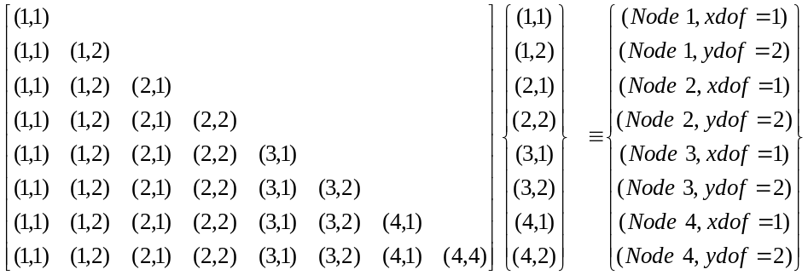

Stiffness matrix output of Nastran in .pch file

DMIG KAAX 0 6 2 0 8 (order of the stiffness matrix. 8X8)
DMIG* KAAX 1 1 (first row up to the diagonal element=(1,1)
* 1 1 2.099611628D+07 (element of stiffness matrix multiplying the dof (1,1))
DMIG* KAAX 1 2 (second row up to the diagonal element=(1,2)
* 1 1 4.037713011D+06 (element of stiffness matrix multiplying the dof (1,1))
* 1 2 6.998702552D+06 (element of stiffness matrix multiplying the dof (1,2))
DMIG* KAAX 2 1 (third row up to the diagonal element=(2,1)
* 1 1-1.866666647D+07 (element of stiffness matrix multiplying the dof (1,1))
* 2 1 2.666666638D+07 (element of stiffness matrix multiplying the dof (2,1))
DMIG* KAAX 2 2 (fourth row up to the diagonal element=(2,2)
* 2 2 1.076923065D+07 (element of stiffness matrix multiplying the dof (2,2))
DMIG* KAAX 3 1 (fifth row up to the diagonal element=(3,1)
* 1 1-2.329449814D+06 (element of stiffness matrix multiplying the dof (1,1))
* 1 2-4.037713011D+06 (element of stiffness matrix multiplying the dof (1,2))
* 3 1 6.467739991D+06 (element of stiffness matrix multiplying the dof (3,1))
DMIG* KAAX 3 2 (sixth row up to the diagonal element=(3,2)
* 1 1-4.037713011D+06 (element of stiffness matrix multiplying the dof (1,1))
* 1 2-6.998702552D+06 (element of stiffness matrix multiplying the dof (1,2))
* 2 2-1.076923065D+07 (element of stiffness matrix multiplying the dof (2,2))
* 3 1 9.635545937D+05 (element of stiffness matrix multiplying the dof (3,1))
* 3 2 2.005159375D+07 (element of stiffness matrix multiplying the dof (3,2))
DMIG* KAAX 4 1 (seventh row up to the diagonal element=(4,1)
* 2 1-7.999999915D+06 (element of stiffness matrix multiplying the dof (2,1))
* 3 1-4.138290177D+06 (element of stiffness matrix multiplying the dof (3,1))
* 3 2 3.074158417D+06 (element of stiffness matrix multiplying the dof (3,2))
* 4 1 1.213829009D+07 (element of stiffness matrix multiplying the dof (4,1))

DMIG* KAAX 4 2 (eight row up to the diagonal element=(4,2)
* 3 1 3.074158417D+06 (element of stiffness matrix multiplying the dof (3,1))
* 3 2-2.283660538D+06 (element of stiffness matrix multiplying the dof (3,2))
* 4 1-3.074158417D+06 (element of stiffness matrix multiplying the dof (4,1))
* 4 2 2.283660538D+06 (element of stiffness matrix multiplying the dof (4,2))

Stiffness matrix output of the fortran code

0.20996E+08 0.40377E+07 -0.18667E+08 0.00000E+00 -0.23294E+07 -0.40377E+07 0.00000E+00 0.00000E+00
0.40377E+07 0.69987E+07 0.00000E+00 0.00000E+00 -0.40377E+07 -0.69987E+07 0.00000E+00 0.00000E+00
-0.18667E+08 0.00000E+00 0.26667E+08 0.00000E+00 0.00000E+00 0.00000E+00 -0.80000E+07 0.00000E+00
0.00000E+00 0.00000E+00 0.00000E+00 0.10769E+08 0.00000E+00 -0.10769E+08 0.00000E+00 0.00000E+00
-0.23294E+07 -0.40377E+07 0.00000E+00 0.00000E+00 0.64677E+07 0.96355E+06 -0.41383E+07 0.30742E+07
-0.40377E+07 -0.69987E+07 0.00000E+00 -0.10769E+08 0.96355E+06 0.20052E+08 0.30742E+07 -0.22837E+07
0.00000E+00 0.00000E+00 -0.80000E+07 0.00000E+00 -0.41383E+07 0.30742E+07 0.12138E+08 -0.30742E+07
0.00000E+00 0.00000E+00 0.00000E+00 0.00000E+00 0.30742E+07 -0.22837E+07 -0.30742E+07 0.22837E+07

Load vector output of Nastran

DMIG* PAX 1 0
* 1 1-8.692391441D+03 (load acting on node 1 in x direction:1)
* 1 2-5.020649943D+03 (load acting on node 1 in y direction:2)
* 2 1 9.094947018D-13 (load acting on node 2 in x direction:1)
* 2 2-5.796402259D+03 (load acting on node 2 in y direction:2)
* 3 1-1.676312023D+03 (load acting on node 3 in x direction:1)
* 3 2 1.427217856D+04 (load acting on node 3 in y direction:2)
* 4 1 1.044870346D+04 (load acting on node 4 in x direction:1)
* 4 2-3.806709905D+03 (load acting on node 4 in y direction:2)

Load vector output of the fortran code

-0.86924E+04
-0.50207E+04
0.00000E+00
-0.57964E+04
-0.16763E+04
0.14272E+05
0.10449E+05
-0.38067E+04

